For Immediate Release

Turn Central to a 9-day Canine Playground
Moved by Series of Ballet and Street Dance Performances

(Hong Kong, July 21, 2021) Reaching the climax stage, SummerFest puts on six events for the upcoming weeks. The new daily programme Home Sweet Woof! Festival welcomes furkids and visitors alike for nine days. Three dance events, namely the classically elegant Fiesta De Ballet, the powerful Zeekers SummerStage and StarShow will shake things up for the audience. Visitors of all ages may also enjoy Pure Music Club: A Euphony of Sounds and Hong Kong Sports Day. There is something for everyone. FREE Admission for ALL activities.

The four daily programmes, Monet Garden, SUMMOJI, Light/Shadow Maze and Living Art Space continue to be available.

Home Sweet Woof! Festival
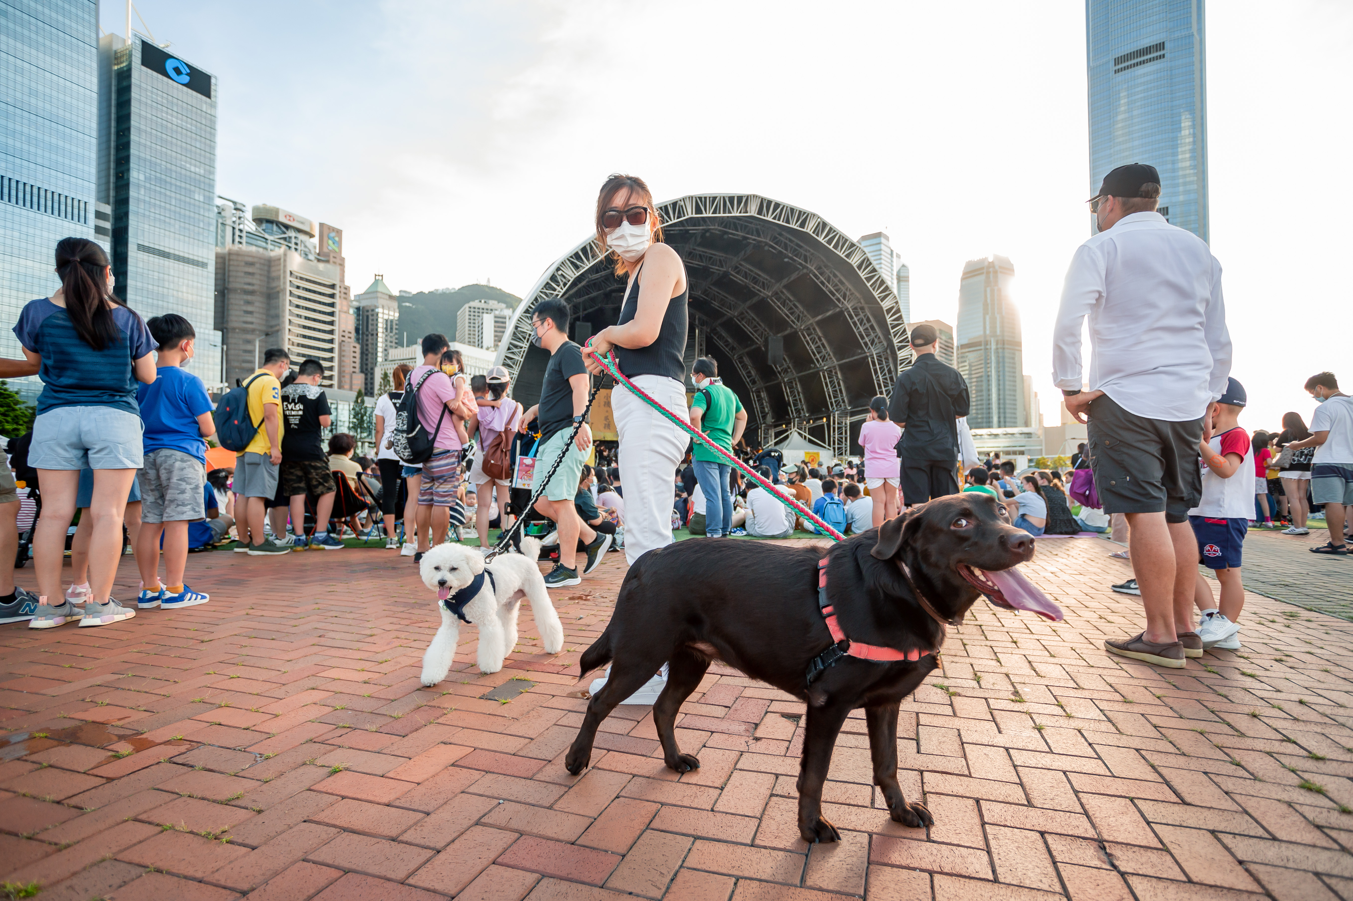
Seize the opportunity to run freely with your doggies in the first-ever outdoor pets carnival at the heart of the CBD. They may tour around in this 36,000-square-metre Central Harbourfront Event Space, or play in an exclusive area equipped with different obstacle facilities for fun and making new friends. Dog training sessions hosted by a professional dog trainer will help pets become smarter and healthier. An on-site pet photographer will capture their amazing, funniest moments. Doggies will also love to visit a pet’s caterer where they may savour dog-only snacks such as the special roasted octopus balls and the Hong Kong-style egg tarts, curry fish ball and other super delicious meals.

A diverse series of nostalgic booth games and handicraft workshops are available for children while everyone may also enjoy visiting a bazaar where more than 80 stalls showcase a wide array of family and pet food and goods. A rarely seen pet ambulance will be on display as well. A "Dog cooling zone" and water buckets are available in the venue, plus pet first-aid services to ensure safety.

Enroll in workshops via http://www.homesweetwoof2021.com

Date: July 29 (Thursday) to August 6 (Friday)
Time: 2pm – 10pm
Venue: Central Harbourfront Event Space
Entrance at Gate 1 (near Central Pier No. 10)

Zeekers SummerStage
Get thrilled at this exciting outdoor party with live street dance performances on stage and a dance mart off stage.

Date: July 29 (Thursday)
Time: 3pm – 10pm
Venue: Central Harbourfront Event Space
Entrance at Gate 3 (near Tamar Park)

Fiesta De Ballet 2021
The popular Netflix K-drama Navillera tells the story of a 70-year-old man who decides to pursue his life-long dream of ballet dancing, which visitors of all ages can also do in Fiesta De Ballet’s workshops. Starting from 7pm, ballet dancers from different studios will participate in a grand show on stage. Audience can enjoy the beauty of ballet dance up close with the iconic harbour as backdrop.

Enroll in workshops via: https://forms.gle/nw1BuBP1PYGEvMwa7

Date: July 30 (Friday)
Time: 3pm – 10pm
Venue: Central Harbourfront Event Space
Entrance at Gate 3 (near Tamar Park)

Pure Music Club: A Euphony of Sounds
This event promises an aural feast of music fusing jazz and electronic music with percussion and wooden musical instruments. With live performances and interactive musical instrument demonstrations, Pure Music Club guarantees the best of a groovy time.

Date: July 31 (Saturday)
Time: 3pm – 9pm
Venue: Central Harbourfront Event Space
Entrance at Gate 1 (near Central Pier No. 10)

Hong Kong Sports Day 2021
With the Tokyo Olympics in full swing, many people have regained their interests in sports. Hong Kong Sports Day provides sports demonstrations, workshops, booth games and family challenges for participants of all ages to enjoy the happiness brought about by exercising.

Date: July 31 (Saturday)
Time: 2pm – 9pm
Venue: Central Harbourfront Event Space
Entrance at Gate 3 (near Tamar Park)

StarShow 2021
Over 30 local dancing teams will participate in StarShow 2021, where dancers can showcase their achievements and persistence on stage via brisk moves, strong beats, and unlimited creativity.

Date: August 1 (Sunday)
Time: 2pm – 9pm
Venue: Central Harbourfront Event Space
Entrance at Gate 3 (near Tamar Park)

Daily Programmes – Monet Garden, SUMMOJI & Light/Shadow Maze
Date: June 26 to August 6
Time: 3pm – 10pm
Venue: Central Harbourfront Event Space
Entrance at Gate 3 (near Tamar Park)

Daily Programme – Living Art Space
Date: July 17 to August 6
Time: 3pm – 9pm
Venue: Central Harbourfront Event Space
Entrance at Gate 1 (near Central Pier No. 10)

High-resolution images can be downloaded at:
https://drive.google.com/drive/folders/1npvRg3ekiHNJ6jYgUJ0Ufj3eH37v8Va2?usp=sharing

For more information:
Facebook https://www.facebook.com/CentralHarbourfrontSummerFest/
Instagram https://instagram.com/summerfesthk/
Website https://www.summerfest-centralharbourfront.hk/

--END--

For media enquiries, please contact:
David Tel: 6626 5762 Email: david@mediamixlimited.com
Louis Tel: 9206 5768 Email: louis@mediamixlimited.com

