For Immediate Release

4 Music and Dance Performances Over the Weekend at SummerFest
500 drummers Attempt to Break World Record
Showtime of Breakdancing to Prepare for Paris Olympics in 2024

(Hong Kong, July 14, 2021) Presenting numerous intoxicating summer events for the public, the 36,000-square-metre open-air Central Harbourfront Event Space is transformed into a giant stage for diversified music and dance performances by the harbour. On July 24 (Saturday), take part in Busking – Generation Y.Z and Hong Kong Ukulele Festival. July 25 (Sunday) brings about Hong Kong Street Dance Festival, Social Inclusive Art Day, plus Hong Kong Rhythmic Gymnastics Carnival held on July 23 (Friday). Free Admission for ALL SummerFest Activities.

The four daily programmes, Monet Garden, SUMMOJI, Light/Shadow Maze and Living Art Space continue to be available.

2021 Hong Kong Rhythmic Gymnastics Carnival
Organised by Hong Kong Youth Rhythmic Gymnastics Association, the first-ever outdoor rhythmic gymnastics carnival in the Territory aims to let more people recognise this dynamic and aesthetic sport. Major programmes include a 3-hour rhythmic gymnastics show with the participation of 150 young athletes, as well as ribbon dance workshops and DIY glitter beads workshops. Visitors of all ages can also take free lessons about basic stretching, fitness games and simple exercises under professional coaching.

Date: July 23 (Friday)
Time: 3pm – 9pm
Venue: Central Harbourfront Event Space
Entrance at Gate 3 (near Tamar Park)

Busking – Generation Y.Z
Busking, with its rising popularity, has nurtured many talented musicians and bands. Local street performance groups who used to perform across different districts will come together at Central Harbourfront Event Space on the event day to show us what they’ve got and interact closely with visitors and fans. Come and witness the new generation’s talents and vitality.

Date: July 24 (Saturday)
Time: 3pm – 6pm
Venue: Central Harbourfront Event Space
Entrance at Gate 1 (near Central Pier No. 10)

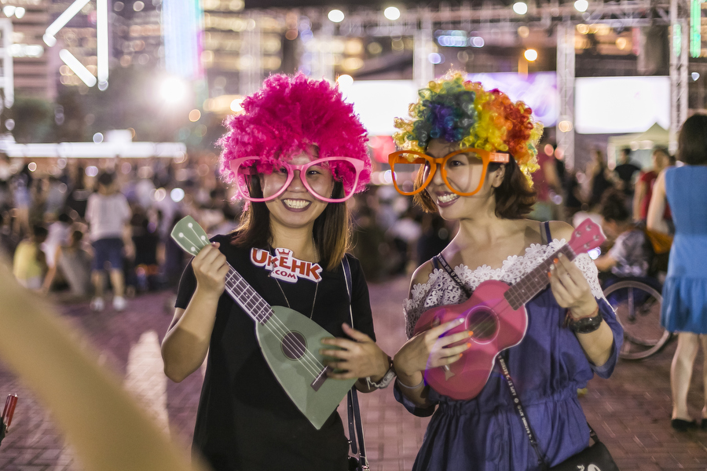
Hong Kong Ukulele Festival 2021
For several years now, Hong Kong Ukulele Festival has been one of SummerFest’s most iconic programmes and a joyous, large-scale music event. Whether you play any musical instruments or not and regardless of age, the tropical Hawaiian ukulele is small and easy for everyone to pick up (both figuratively and literally!) In addition to the performances on stage, there are also some game booths, music, and handicraft workshops. Visitors can try out the ukuleles at the romantic Central Harbourfront.

Date: July 24 (Saturday)
Time: 4pm – 8:30pm
Venue: Central Harbourfront Event Space
Entrance at Gate 3 (near Tamar Park)

Hong Kong Street Dance Festival
While break dancing gets Olympic status to debut at Paris Games in 2024, Hongkongers may now watch up close as local street dancers show off their coolest style. Co-organised by Hong Kong Street Dance Development Alliance, Hong Kong Street Dance Festival bring visitors a brilliant performance regarding the flourishing art of street dancing, plus family workshops and DJ party. A total of 25 top-of-the-game local dance teams and crews will compete in the street dance choreography competition as a stunning finale of the night.

Date: July 25 (Sunday)
Time: 3pm – 9pm
Venue: Central Harbourfront Event Space
Entrance at Gate 1 (near Central Pier No. 10)

Social Inclusive Art Day
Organised by ADAM, the social enterprise set up by Arts with the Disabled Association Hong Kong, this event aims at promoting social inclusion. Through the determinate work spirit of artists with disabilities, it inspires us to strive for the best. On Social Inclusive Art Day, 500 drummers will attempt to break the world record of drum playing. Renowned visually impaired pianists Lee Shing and Lee Hin, other artists with disabilities, students from secondary, primary and special schools, Hong Kong Juvenile & Youth Chinese Classical Orchestra, as well as other music and dance groups will take turn to perform on the stage for the entire day. Aside from enjoying their performances, visitors can also participate in children’s drawing competition, booth games, large-scale collages and more.

Date: July 25 (Sunday)
Time: 3pm – 9pm
Venue: Central Harbourfront Event Space
Entrance at Gate 3 (near Tamar Park)

Daily Programmes – Monet Garden, SUMMOJI & Light/Shadow Maze
Date: June 26 to August 6
Time: 3pm – 10pm
Venue: Central Harbourfront Event Space
Entrance at Gate 3 (near Tamar Park)

Daily Programme – Living Art Space
Date: July 17 to August 6
Time: 3pm – 9pm
Venue: Central Harbourfront Event Space
Entrance at Gate 1 (near Central Pier No. 10)
High-resolution images can be downloaded at:
https://drive.google.com/drive/folders/1npvRg3ekiHNJ6jYgUJ0Ufj3eH37v8Va2?usp=sharing

For more information:
Facebook https://www.facebook.com/CentralHarbourfrontSummerFest/
Instagram https://instagram.com/summerfesthk/
Website https://www.summerfest-centralharbourfront.hk/

--END--

For media enquiries, please contact:
David Tel: 6626 5762 Email: david@mediamixlimited.com
Louis Tel: 9206 5768 Email: louis@mediamixlimited.com

